COAL LAB MANUAL

**Submitted to:**

Dr. Tauqir

Teacher assistant : Sir Shahzad

**Submitted By:**

Komal Shehzadi

Registeration no : 2016-CS-178

**Section:**

Section B

**Department:**

Department of Computer Science

**Institute:**

University of Engineering and Technology Lahore (Main Campus)



**Date of Submission:** March 29, 2018

# LAB 6

## Task: Take a string from data segment and display vowels in it and count number of vowel in it and display count on screen

The description inside the “// ‘ ‘ // “ are the comments to make the code more clear. These are not the part of program.

**// PROGRAM //**

**// Libraries to include //**

.model

.stack

**// DATA SEGMENT //**

.data

str DB 'abcdeiiiiiighiklohoyekoe$'

counter DB 0

**// CODE SEGMENT //**

.CODE

**// loads the starting address of string in BX register//**

mov ax, @data

mov ds, ax

lea bx, str

mov dh, 0h

mov ah, 2h

mov CX, 40h

**// LABEL l1 //**

**// Reads the string and jump on specific label //**

l1:

mov al, [bx]

INC bx

CMP al, 'a'

JE l3

CMP al, 'e'

je l3

CMP al, 'i'

je l3

CMP al, 'o'

je l3

CMP al, 'u'

je l3

CMP al, '$'

JE l4

JNE l1

**// LABEL l3 //**

**// It prints a new line and the character in AL register on screen//**

l3:

inc DH

mov CL, AL

mov DL, 0ah

int 21h

mov DL, 0dh

int 21h

mov DL, CL

int 21h

inc counter

jmp l1

**// LABEL l4 //**

**// prints number of vowels, count, on screen and then jumps on exit label //**

l4:

mov dl, 0ah

int 21h

mov dl, 0dh

int 21h

mov al, 00h

mov ah, 00h

mov al, counter

mov bl, 10

div bl

mov bl, al

mov bh, ah

mov ah, 2

mov dl, bl

add dl, 30h

int 21h

mov dl, bh

add dl, 30h

int 21h

JMP exit

**// LABEL exit //**

exit:

.exit

**// END//**

## Commands:

**.model:** it is used to tell the assembler that program is in protected mode.

**.code:** it contains all the codes and commands.

**.data:** it contains all the definitions and declarations of variables.

**Labels:** these are the customized names of specific code segment to call that code segment anywhere in program by its name

LABEL_NAME:

Write the code here.

**MOV:** Moves the contents of source instruction in destination and the syntax is as follows:

Mov Destination, Source

**INT 21H:** Call to DOS interrupt Handler.

INT 21H

**INC :** unary operator increment, used to add 1 in the contents of source.

INC Source

**LEA:** Load effective address of a memory block in a register it moves the starting address of a memory block in a register.

LEA Source, Destination

**JMP:** JMP command is used for unconditional jump on a label.

JMP LABEL_NAME

**CMP:** CMP is used to compare the contents of two register or variables and give a value in result if source is less than , greater than or equal to destination then -1, 1 or 0 is returned by CMP respectively.

CMP Source, Destination

**JNE:** in the result of CMP command this label will be executed if the contents of source and destination are not equal and by this we can jump on a label

JNE LABEL_NAME

**JLE:** In the result of CMP command this label will be executed if the contents of source is less or equal to destination by this we can jump on a label

JLE LABEL_NAME

**JE:** In the result of CMP command this label will be executed if the contents of source and destination are equal and by this we can jump on a label

JE LABEL_NAME

**JL:** In the result of CMP command this label will be executed if the contents of source is less than destination by this we can jump on a label

JL LABEL_NAME

**JG: :** In the result of CMP command this label will be executed if the contents of source is greater than destination by this we can jump on a label

JG LABEL_NAME

**JGE:** In the result of CMP command this label will be executed if the contents of source is greater or equal to destination by this we can jump on a label

JGE LABEL_NAME

**.exit:** Command to exit the program.

## OUTPUT :

The following output screen will be displayed for 'abcdeiiiiiighiklohoyekoe$' string all the vowels in it are printed one by one and the number of vowels are also printed.

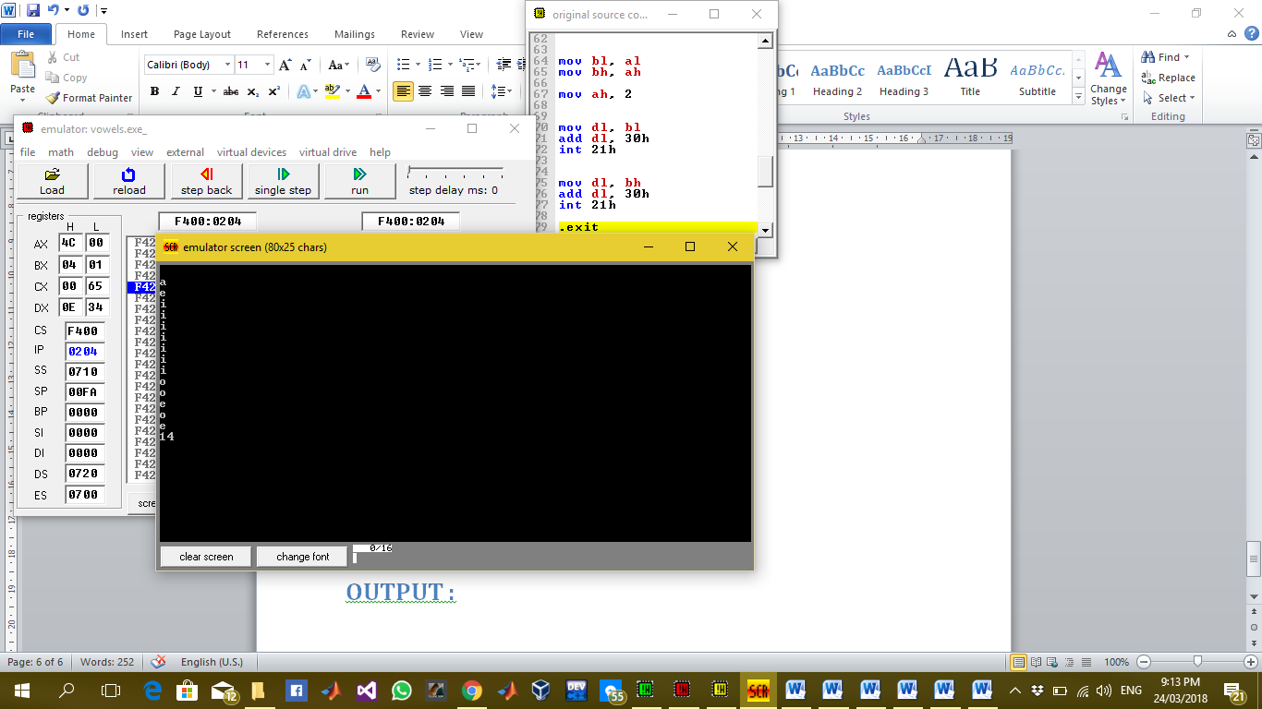

## Description:

In this lab we have to take a string from data segment suppose str and read it character by character and print the vowels in it and count the number of vowels and print the count on screen. For this purpose I have used multiple labels and CMP statements to compare vowels and jump on different labels to display the vowel and increment the count and when the string is finished the count will be display to display the count we have used div statement to get its quotient and remainder if it is a two digit number as shown in example string we divide it by 10 and the display the quotient and remainder on screen using div command we separate it parts and then print them one by one.